**GOVERNMENT OF MIZORAM**

**OFFICE OF THE CHIEF MEDICAL OFFICER**

**SIAHA DISTRICT: SIAHA**

**No.C.11011/3/ 2016- CMO (S)/ NHM– DPMSU/ Dated 28th June 2022**

To,

The Deputy Comissioner,

Siaha District : Siaha

Mizoram.

Subject: Submission of Brief write up report of National Health Mission, Siaha District achievements, ***Jan-March 2021, 2021 April –2022 March, 2022 April -May 2022*** for DDCMC/Disha meeting.

Sir,

I have the honor to submit here with Brief write up report of National Health Mission, Siaha District achievements, since April – ***since 2020 Jan.-March 2021 (4th quarter), April 2021 –2022 March and April 2022 – 2023 June (1st  Quarter)*** for DDCMC/Disha meeting.

This is for your kind information and necessary action.

*Enclosed: As stated above*

Yours Faithfully,

(Dr.LALNUNZIRI)

Chief Medical Officer

Siaha District : Siaha

**PROGRESS MADE UNDER HEALTH DEPARTMENT, SIAHA DISTRICT**

**SINCE 4th Qtr,2020 - 2021 , 2021 – 2022, 2022-2023 1st Quarter.**

|  |  |  |
| --- | --- | --- |
| **A** | **Dist.Health Profile** | **Current Status** |
| 1 | Population | 68454 |
| 2 | District Hospital | 1 |
| 3 | Number of PHC | 4 |
| 4 | No. of Sub-Centres & Clinics | 24 SC ­& 13 Clinics |
| 5 | No.of GDMO in District Hospital including AYUSH & Dental Surgeon | 3 (1 AYUSH) |
| 6 | No.of Specialist Doctor | 5 |
| 7 | No. of Eligible Couple | 6939 |
| 8 | Pregnant Women target | 1646 |
| 9 | Infant target | 1445 |
| 10 | No. of Village Health &Sanitation Committee | 77 |
| 11 | No of ASHA | 77 |
| 12 | No of Sub Centre without Health Worker | 9 (Amotlah,N.Laty,College vaih,New Colony,Mawhro,Chheihlu,Theiri,Vahia,Miepu) |
| 13 | No.of Health Workers | 31(16R + 15C) (16F + 15 M) |
| 14 | No. of Health & Wellness Officer | 16(2 CHO + 14 HWO) |
| 15 | No.of Health Supervisors | 7(2M + 5F) |
| 16 | No.of Staff Nurse in PHC | 9(3 R + 6 C) |
| 17 | No.of Staff Nurse in DH | 19(9R +10C) |
| 18 | No.of Sub Centre conducting delivery | 24 |
| 19 | Civil Works |  |

|  |  |  |  |  |
| --- | --- | --- | --- | --- |
| ***B*** | ***Physical Activities under Maternal Health*** | ***Jan - Mar. 2021*** | ***April - March,***  ***21 - 22*** | ***April -May***  ***22 - 23*** |
| 1 | No. of ANC checkup | 415 | 1395 (97%) | 250 (23%) |
| 2 | Total Delivery | 311 (75%) | 1362 (98%) | 202 (81%) |
| 3 | Total Live Birth | 310 (100%) | 1345 (98%) | 197 (98%) |
| 4 | No.of still birth | 1 (0.3%) | 26 (2%) | 6 (2%) |
| 5 | No.of Institutional delivery (DH,PHC & SC) | 239 (77%) | 1133 (83%) | 177 (88%) |
| 6 | No.of Home Delivery | 72 (23%) | 229 (17%) | 25 (12%) |
| 7 | No.of Severe Anaemia detected & treated | 2 (0.5%) | 14 (1%) | 4 (2%) |
| 8 | No.of High Risk pregnant women detected & treated | 15 (5%) | 60 (4%) | 21 (8%) |
| 9 | No.of Pregnant women given 360 Calcium tablets free of cost | 39 (13%) | 663 (80%) | 122 (60%) |
| 10 | No. of Pregnant women given 180 IFA tablet | 235 (76%) | 930 (68 %) | 101 (50%) |
| 11 | No. of Pregnant women given Albendazole tablets free of cost after 1st trimester | 230 (55%) | 1034 (74%) | 190 (84%) |
| 12 | **Maternal Mortality Ratio (No.of Maternal death x 1,00,000/No.of live births)** | 0 | 0 | 0 |
| 13 | No.of Maternal Death | NIL | NIL | NIL |
| ***C*** | ***Physical Activities under Child Health*** | ***Jan.- Mar. 2021*** | ***April - March,***  ***21 - 22*** | ***April -May 22 - 23*** |
| 1 | Total Live Birth | 310(100%) | 1345 (96%) | 197 (95%) |
| 2 | No. of Infant Death | 12 | 24 | 5 |
| 3 | **Infant Mortality Rate (No. of Infant death x 1000/No. of live births)** | **39** | 18 | 25 |
| 4 | No. of Child death (1yr -5yrs) | 0 | 3 | 1 |
| 5 | **Under 5 Mortality Rate (No. of Child death x 1000/No. of live births)** | **0** | **2** | **5** |
| 6 | No. of Low Birth Weight (Less than 2.5kgs at birth) | 14 | 41(3%) | 10(5%) |
| 7 | No. of Fully Immunized (Below 1 yr) | 323 (104%) | 1138 (85%) | 187(95%) |
| 8 | No. of babies admitted at Sick New Born Care Unit (SNCU) | 2 | 132 | 15 |
| 9 | No. of Low Birth Weight/Pre Term treated at SNCU | 2 | 24/12 | 4 |
| 10 | No. of infant death at Sick New Born Care Unit (SNCU) | 1 | 6 | 3 |
| 11 | No.of Home Based New born Care Complete visit by ASHA | 229 | 854 | 28 |
| 12 | No. of HBNC funds given to ASHA @Rs.250 per HBNC Complete visit | 62(62x250=Rs.57250) | NIL | NIL |
| 13 | No.of Covid -19 incentives given to ASHA @Rs.1000 per months | 76 | NIL | NIL |
| ***D*** | ***Other Activities under National Health Mission*** | ***Jan.- Mar. 2021*** | ***April - March,***  ***21 - 22*** | ***April -May***  ***22 - 23*** |
| 1 | No. of Out Patient Department cases  (DH, PHC & SC) | 12623 | 61172 | 12190 |
| 2 | No. of In Patient Department cases (DH & PHC) | 911 | 30307 | 734 |
| 3 | No. of Village Health & Nutrition Day held | 137 | 540 | 88 |
| 4 | No. of United funds given at Sub Centre. For SC @Rs.6054/- & for Clinic @2500/- each. (Total @Rs.1,80,296/-) | 0 | 24 SC & 13 Clinics | NIL |
| 5 | No. of Rogi Kalyan Samiti funds given @ Rs.52,750 for PHC & Rs.3,00,000 for DH | 0 | 4 PHC& 1 DH | -NIL |
| 6 | No. of VHSNC funds given @Rs.5000/- per VHSNC | 0 | 77 (VHSNC) | 77(VHSNC) |
| 7 | No.of Covid -19 incentives given to Sub Centre @Rs.5000 each and Rs.4000 each to Sub Centre Clinic | 0 | 15 SC | NIL |
| 8 | No.of Covid -19 Emergency Response fund given to PHC @Rs.20,000/- each & DH @ Rs.4,00,000/- | 0 | 4 PHC | NIL |
| 9 | No.of Janani Suraksha Yojana funds given to |  |  |  |
|  | Pregnant Mother (@ Rs.700 per Mother) | 163 (68%) | 704(62%) | 146(82%) |
|  | Accredited Social Health Activist(@ Rs.600 per ASHA) | 165 (69%) | 639(56% | 24(14%) |
| 10 | No.of JSSK beneficiary - Mother | 216 (90%) | 1121(99%) | 172(97%) |
| 11 | No.of JSSK beneficiary - Sick Infants | 63 | 220 | 38 |

|  |  |  |  |  |
| --- | --- | --- | --- | --- |
| ***E*** | ***Activities under ABPMJAY*** | ***Jan.- Mar. 2021*** | ***April - March,***  ***21 - 22*** | ***April -May***  ***22 - 23*** |
| 1 | No. of Golden card holder | 15412 | 122 | 64 |
| 2 | No. of free treatment given under ***ABPMJAY*** at Dist. Hosp. Siaha | 33 | 185 | 28 |
| 3 | Reimbursement under ***Mizoram State Health Care Scheme*** | 82 | 246 | 52 |
| ***F*** | ***Activities under Mizoram State AIDS Control Society*** | ***Jan.- Mar. 2021*** | ***April - March,***  ***21 - 22*** | ***April -May***  ***22 - 23*** |
| 1 | No. of blood tested for HIV screening | **503** | **1320** | **230** |
|  | Male | 391 | 1010 | 177 |
|  | Female | 112 | 310 | 53 |
| 2 | No. of positive cases | **17** | **67** | **21** |
|  | Male | 14 | 53 | 20 |
|  | Female | 3 | 14 | 1 |
| 3 | No.of blood tested for HIV screening (Pregnant Women) | **328** | **973** | **28** |
|  | No. of positive cases | 2 | 6 | 0 |
| 4 | No. of Death | 0 | 1 | 0 |

|  |  |  |  |  |
| --- | --- | --- | --- | --- |
| ***G.*** | ***Activities under National Vector Borne Disease Control Programme (NVBDCP)*** | ***Jan.- Mar. 2021*** | ***April - March,***  ***21 - 22*** | ***April -May***  ***22 - 23*** |
| 1 | No. of blood tested for Malaria screening | 1845 | 12571 | 2621 |
|  | Positive | 13 | 437 | 161 |
|  | PF Cases | 5 | 173 | 29 |
|  | PV Cases | 8 | 264 | 132 |
| 2 | No. of Malarial Death | Nil | 0 | 0 |

|  |  |  |  |  |
| --- | --- | --- | --- | --- |
| ***H.*** | ***Activities under National Programme on Prevention & Control of cancer, Diabetes, CDVs& Stroke (NPCDCS)*** | ***Jan.- Mar. 2021*** | ***April - March,***  ***21 - 22*** | ***April -May***  ***22 - 23*** |
| 1 | No.of persons attended Non Communicable Disease (NCD) Clinic | 2175 | 5603 | 976 |
| 2 | No.of newly diagnosed patients put on treatment with follow up |  |  |  |
|  | 1. Hypertension | 160 | 203 | 64 |
|  | 1. Diabetes | 110 | 420 | 109 |
|  | 1. Hypertension & Diabetes | 24 | 24 | 2 |
|  | 1. Cardio Vascular Diseases | 0 | 1 | 0 |
|  | 1. Stroke | 3 | 25 | 5 |
| 3 | No. of Patients counseled for Health Promotion & Prevention of NCDs | 273 | 623 | 173 |
| 4 | No.of Patients underwent Physiotherapy | 53 | 150 | 32 |
| 5 | No. of screened for TB Symptoms | 14 | 45 | 4 |
| ***I.*** | ***Activities under National Tuberculosis Elimination Programme*** | ***Jan.- Mar. 2021*** | ***April - March,***  ***21 - 22*** | ***April -May***  ***22 - 23*** |
| 1 | Total No. of Patients | 23 | **94** | **37** |
| 2 | Patient microbiology confirmed | 15 | **57** | **19** |
| 3 | Clinically Diagnosed | 8 | **57** | **18** |
| 4 | HIV patients | 1 | **6** | **5** |
| 5 | No.of Cured | 29 | **28** | **0** |
| 6 | No.of treatment complete | 16 | **32** | **0** |
| 5 | No.of Death | 1 | **2** | **0** |

|  |  |  |  |  |
| --- | --- | --- | --- | --- |
| ***J.*** | ***Activities under Mental Health Programme*** | ***Jan.- Mar. 2021*** | ***April - March,***  ***21 - 22*** | ***April -May***  ***22 - 23*** |
| 1 | No. of Out Patient Department cases | 136 | 483 | 127 |
| 2 | No. of In Patient Department cases | 23 | 74 | 26 |
| 3 | No. of Awareness Campaign | 6 | 9 | 3 |
| 4 | No. of Free Clinics held | 1 | 0 | 3 |
| 5 | No. of Patients | 23 | 0 | 122 5 |
| 6 | No. of Call attended by Social Worker | 2 | 33 | 0 |

|  |  |  |  |  |
| --- | --- | --- | --- | --- |
| ***K.*** | ***Activities under ART Centre*** | ***Jan.- Mar. 2021*** | ***April - March,***  ***21 - 22*** | ***April -May***  ***22 - 23*** |
| 1 | New Client | 19 | 77 | 30 |
| 2 | Transfer In | 8 | 40 | 10 |
| 3 | Total | 27 | 117 | 40 |
| 4 | Pregnant women | 2 | 11 | 1 |
| 5 | Hep - C | 1 | 24 | 18 |

|  |  |  |  |  |
| --- | --- | --- | --- | --- |
| ***L.*** | ***Activities under ORAL SUBSTITUTION THERAPY*** | ***Jan.- Mar. 2021*** | ***April - March,***  ***21 - 22*** | ***April -May***  ***22 - 23*** |
| 1 | No.of active Clients | 360 | 329 | 314 |
| 2 | New Registration | 10 | 1 | 0 |
| 3 | Death | - | 2 | 6 |
| 4 | Migration | 5 | 0 | 0 |
| 5 | Imprisonment | 3 | 0 | 0 |

|  |  |  |  |  |  |  |  |  |  |  |  |  |  |  |
| --- | --- | --- | --- | --- | --- | --- | --- | --- | --- | --- | --- | --- | --- | --- |
| **M. COVID VACCINATION STATUS IN SIAHA DISTRICT** | | | | | | | | | | | |  | |  |
| ***Months (From Dt.16.1.21)*** | ***HCW*** | | | | ***FLW*** | | | ***12 Yrs*** | | ***15yrs*** | | ***18 yrs*** | | | |
| ***1st dose*** | ***2nd dose*** | ***Pre***  ***dose*** | ***1st dose*** | | ***2nd dose*** | ***Pre***  ***dose*** | ***1st dose*** | ***2nd dose*** | ***1st dose*** | ***2nd dose*** | ***1st dose*** | ***2nd dose*** | | |
| **Till Date**  **20.06.2022** | 562 | 484 | 217 | 1120 | | 940 | 222 | 2336 | 842 | 3430 | 1909 | **26436** | **18117** | | |
|  | | | | | | | | | | | | | | | |

|  |  |  |  |  |  |  |
| --- | --- | --- | --- | --- | --- | --- |
| ***)*** | ***45 yrs +*** | | ***60 yrs +*** | | ***Total Vaccinated*** | |
| ***1st dose*** | ***2nd dose*** | ***1st dose*** | ***2nd dose*** | ***1st dose*** | ***2nd dose*** | ***Pre***  ***dose*** |
| **Till Date**  **20.06.2022** | 7590 | 6441 | 2889 | 729 | 44758 | 31622 | **1168** |

|  |  |  |  |  |  |  |
| --- | --- | --- | --- | --- | --- | --- |
| ***12 to 14 yrs*** | | | | | | |
| Target | 1st Dose | 2nd Dose |  | % 1st of Dose | % of 2nd Dose |  |
| 3245 | 2336 | 842 |  | 72 % | 36 % |  |
| 15 to 17 yrs | | | | | | |
| Target | 1st Dose | 2nd Dose |  | % 1st of Dose | % of 2nd Dose |  |
| 2716 | 3430 | 1909 |  | 126 % | 56 % |  |
| 18 to 44 yrs | | | | | | |
| Target | 1st Dose | 2nd Dose |  | % 1st of Dose | % of 2nd Dose |  |
| ***26268*** | 26436 | 18117 |  | 101 % | 69 % |  |
| 45 yrs Above | | | | | | |
| Target | 1st Dose | 2nd Dose |  | % 1st of Dose | % of 2nd Dose |  |
| ***13392*** | 10874 | 9330 |  | 81 % | 86 % |  |

|  |  |  |  |  |
| --- | --- | --- | --- | --- |
| **COVID – 19 STATUS REPORT** | | | | |
|  | ***COVID -19 Positive Cases*** | ***Jan.- Mar. 22021*** | ***April - March,***  ***21 - 22*** | ***April -May***  ***22 - 23*** |
| a. | No.of Sample tested | 988 | 58489 | 385 |
|  | RAgT | 786 | 55290 | 385 |
|  | Truenat | 202 | 3199 | 0 |
| b. | Total No of Positive cases | 1 | 6717 | 23 |
| c. | Positivity Rate | 0.05 % | 11.48 | 5.97 |
| d. | No of Positive case below 18yrs | 0 | 1007 | 12 |
| e. | No.of Pregnant women Positive | 0 | 134 | 1 |
| f. | No.of Positive Death | 0 | 21 | 0 |
| g. | No.of Positive cases among Covid-19 Vaccine beneficiary | 0 | 3997 | 10 |
| h. | Total No.of Discharged | 1 | 6696 | 23 |
| i. | Total number of Active cases | 0 | 0 | 0 |

|  |  |  |
| --- | --- | --- |
| **K** | **Shortfalls** | **Suggestions** |
| **1** | **Presently there are 9 Sub Centres without Health Workers Amotlah, N.laty, College Vaih, N.Colony, Mawhro, Chheihlu,Theiri, Vahia, Miepu** | **Posting of 9 Health Workers to make the Sub Centre functional** |
| **2** | **Out of 37 SCs in a district, 25 SCs are functional with only one Health Worker** | **According to IPHS standard, there should be 2 HWs(1Male &1Female) in every Sub Centre for better & smooth functioning of all the Health Programmes at Sub Centre level** |
| **3** | **IV Grade / Helper not available in 13 SCs** | **Posting of IV Grade for 13 Sub Centers for better & smooth functioning of the Sub Centre** |
| **4** | **Labour Room Centres were very small and congeted needs renovation** | **Renovation of Labour Room at 13 Sub Centres** |

**Complete construction**

**PHURA PHC**

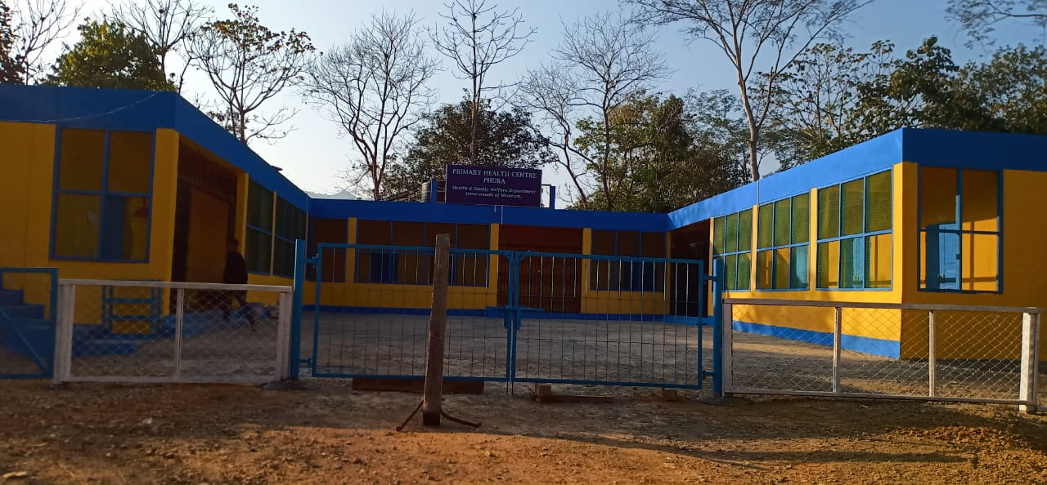

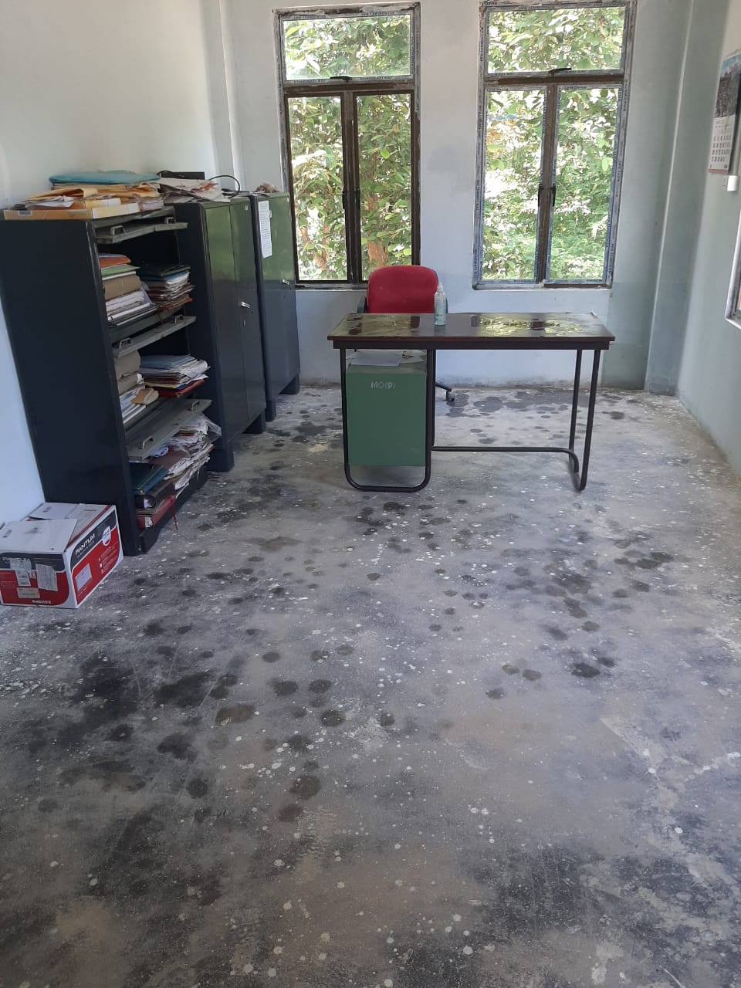



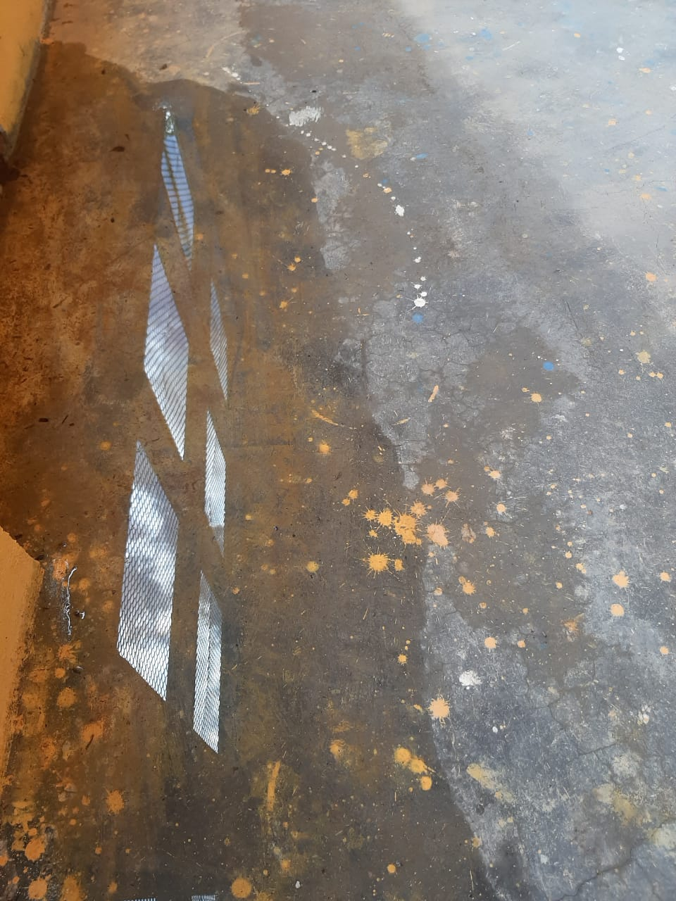

***COMPLETE CONSTRUCTION***

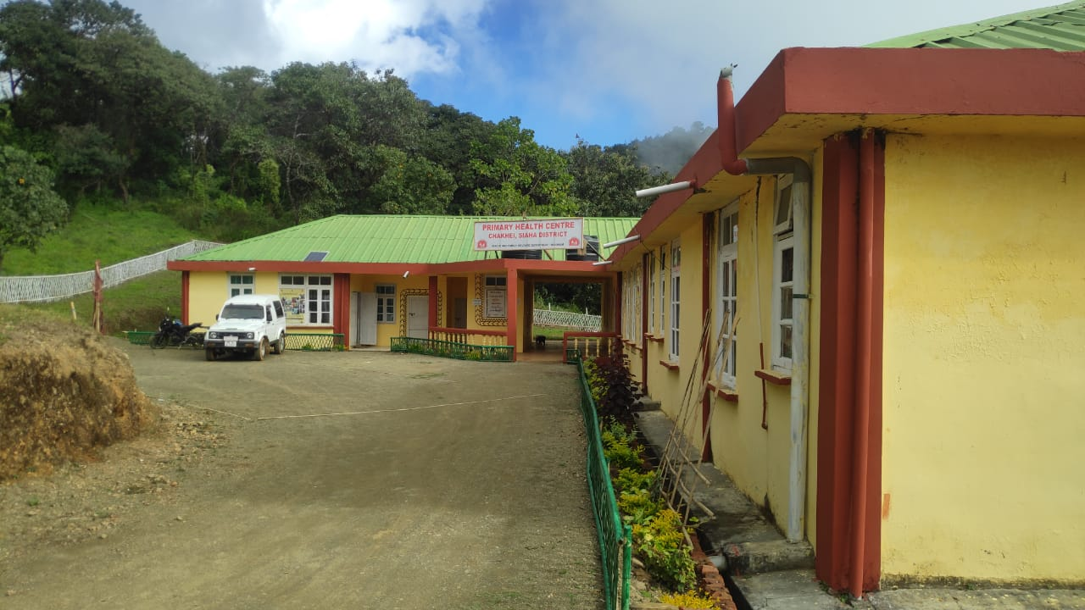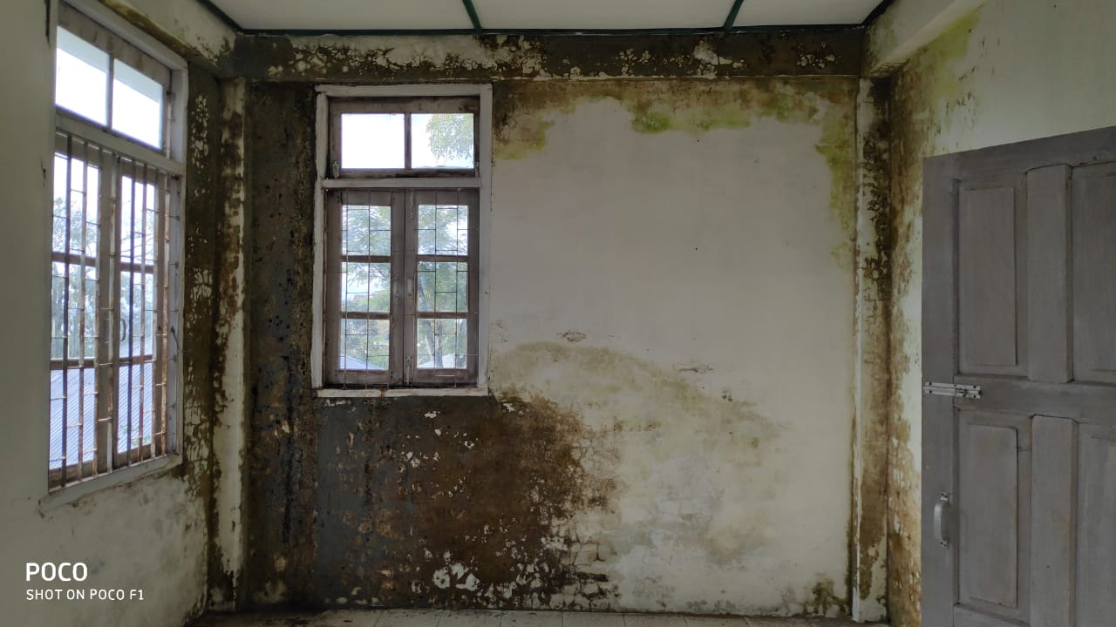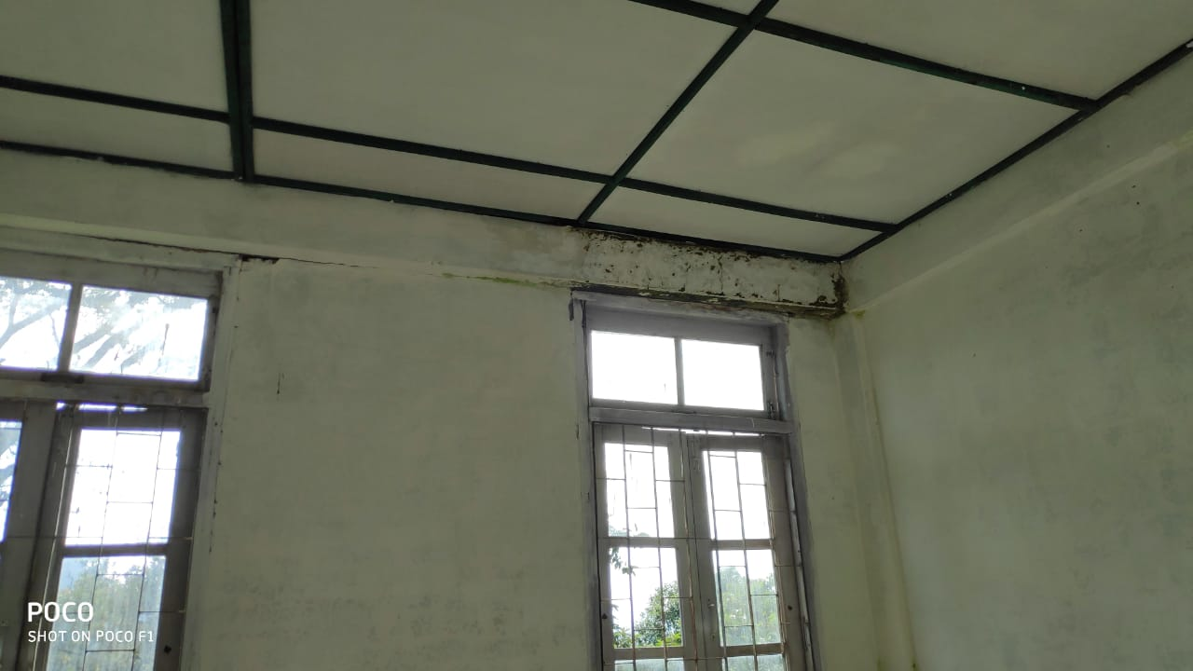***CHAKHEI PHC***

**COMPLETE CONSTRUCTION**

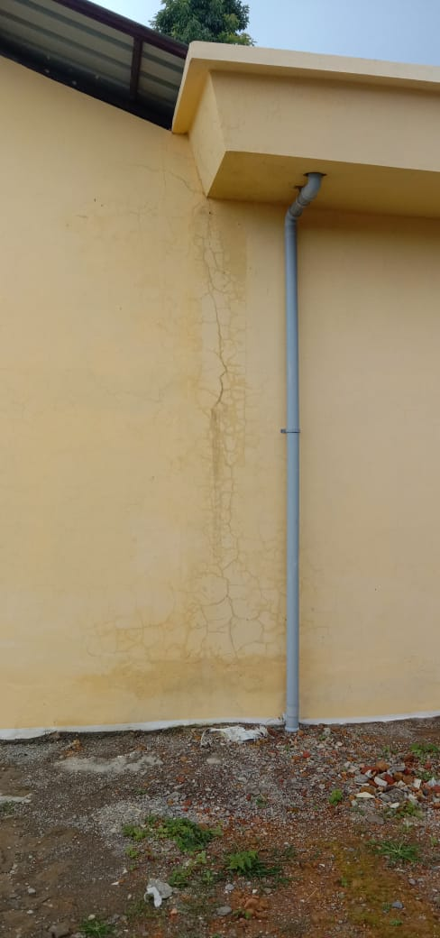 TIPA PHC 